 Assignment 4

Name : Aditya Latke
PRN : 1262252462
DIV : 1

PROBLEM STATEMENT: Write a C Program to calculate the salary of an employee given his basic pay (taken as input from the user). Calculate gross salary of employee. Let HRA be 10 % of basic pay and TA be 5% of basic pay. Let employees pay professional tax as 2% of total salary. Calculate net salary payable after deductions.

OBJECTIVE:

1. To understand the importance of flowchart for any programming model.
2. To learn simple flowchart symbols and arrows to define relationships.
3. To understand and develop visual representations of flow of data.

THEORY:
1. Define Algorithm.
An algorithm is a finite sequence of well-defined and unambiguous steps used to solve a problem or perform a task, which produces output for given input and terminates after a finite number of steps.
2. What are the different characteristics of an algorithm.
The important characteristics of an algorithm are:
- Input
An algorithm must accept zero or more inputs.
- Output
An algorithm must produce at least one output.
- Definiteness
Each step of the algorithm must be clear, precise, and unambiguous.
- Finiteness
The algorithm must terminate after a finite number of steps.
- Effectiveness
Every step must be simple, executable, and feasible in a real system.
- Generality
An algorithm should be applicable to all valid inputs, not just a single case.

PLATFORM: Linux
ALGORITHM:
- Start
- Read basic pay
- Calculate HRA = 10% of basic pay
- Calculate TA = 5% of basic pay
- Calculate gross salary = basic + HRA + TA
- Calculate tax = 2% of gross salary
- Calculate net salary = gross − tax
- Display net salary
- Stop

INPUT:

#include <stdio.h>

int main()
{
float basic, hra, ta, gross, tax, net;

printf("Enter Basic Pay: ");
scanf("%f", &basic);

hra = 0.10 * basic;
ta = 0.05 * basic;

gross = basic + hra + ta;

tax = 0.02 * gross;

net = gross - tax;

printf("\nBasic Pay = %.2f", basic);
printf("\nHRA (10%%) = %.2f", hra);
printf("\nTA (5%%) = %.2f", ta);
printf("\nGross Salary = %.2f", gross);
printf("\nProfessional Tax = %.2f", tax);
printf("\nNet Salary = %.2f", net);

return 0;
}
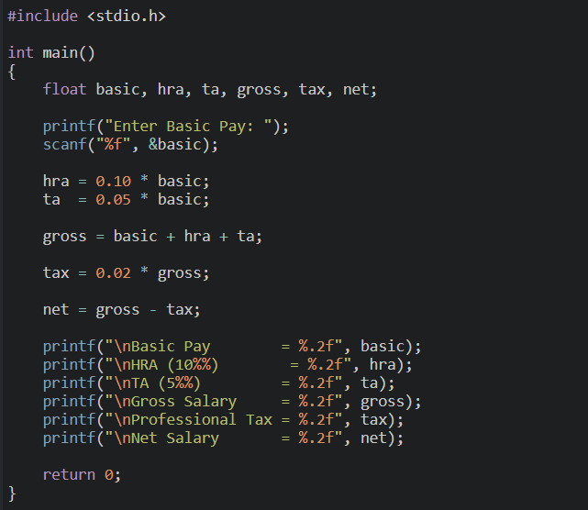

OUTPUT:
Enter Basic Pay:
Basic Pay = 10000.00
HRA (10%) = 1000.00
TA (5%) = 500.00
Gross Salary = 11500.00
Professional Tax = 230.00
Net Salary = 11270.00
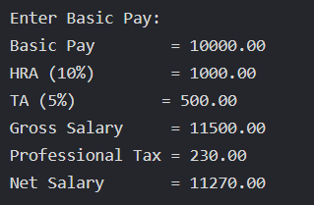

CONCLUSION: Thus, we have learned to write algorithms and to draw its representation in terms of flowchart.

FAQs:
1. Describe various symbols and their use in flowchart.
2. Difference between Algorithm and Flowchart.

